
press release
(English translation)

IEG PRESENTS THE 27TH EDITION OF ECOMONDO:
INNOVATION, TECHNOLOGY AND BEST EUROPEAN PRACTICES AT THE CENTRE OF THE GREEN TRANSITION AND PRESENT AND FUTURE ECONOMIC GROWTH
- From 5th to 8th November, Ecomondo, Europe and the Mediterranean basin’s leading event for the green and circular economy to meet the objectives of the European Green Deal, will be back at Rimini Expo Centre.
- A more extensive thematic offer with focus on Innovation and technology for the prevention and mitigation of climate change through the use of Big Data and AI.
- 137,000 m² of floor space with two new temporary halls in response to the growing demand from companies. About 900 buyers and industrial and institutional delegations from the Balkan area, Sub-Saharan Africa, North Africa, the Middle East and Latin America are expected to attend.
Rimini, 9th May 2024 – Sustainability and ecological transition are consistently strategic areas for the competitiveness of Italian companies on foreign markets. Companies that look to the future and that will be key players at Ecomondo 2024 (Rimini Expo Centre, 5th – 8th November), the trade show organised by Italian Exhibition Group (IEG), this year at its 27th edition. In 2023, Italian exports, with the sustainability segment as the driving force, exceeded 660 billion euros, a figure that is expected to rise by a further 10% this year and by an average of 14.1% over the next two years due to the ever-increasing impetus of transition processes.
In this scenario, after last year's record-breaking edition, Ecomondo 2024 will once again feature numbers and projects that reconfirm its role as Europe and the Mediterranean basin’s international reference event for technologies, services and industrial solutions in the green and circular economy sectors.
A research and innovation hub, Ecomondo will be a place for sharing and co-designing the policies of the European Green Deal, where experts, decision makers, entrepreneurs and sector professionals will discuss the challenges and opportunities linked to environmental policy and the transition towards a circular economy.
With ever-greater focus on internationalisation, delegations from 120 countries and 60 international trade associations are expected to attend the coming edition and collaborations with over 100 foreign trade magazines have been set up to increase the event’s role as a meeting place between “Made in Europe” best practices and the international demand for green transition solutions.
Moreover, the trade show will provide a place for dialogue and discussion on the sustainability challenges and “green” socio-economic development of the African continent, the focus of the Italian Government's Mattei Plan.
The main themes at Ecomondo 2024, around which the exhibition area and the full programme of events and conferences will be developed, will be: Big data, artificial intelligence and predictive systems for ecological transition and climate change effect management; New space economy for environmental surveillance and earth observation; Agriculture 4.0 to maximise yields and protect crops; Urban mining for the recovery of precious and critical materials from WEEE.
These will complement and enrich the new edition’s six core thematic macro-areas: Waste as Resource, Water Cycle & Blue Economy, Circular & Regenerative Bio-economy, Bio-Energy & Agroecology, Sites & Soil Restoration, Environmental Monitoring & Control.
The exhibition layout will be renewed and extended. In fact, the construction of two new temporary halls will take the exhibition area to 137,000 square metres. Five exhibition districts will feature projects targeting vertical industries, including the Textile District, which will candidate Ecomondo as the capital of ethical fashion; the Paper District, a meeting place for all players in the paper supply chain; and the Blue Economy area to minimise negative impacts on the marine ecosystem and promote its resilience and regeneration. These will be joined by the Innovation District, where 30 start-ups will be exhibiting in the Start-Up & Scale-Up area, while the Green Jobs & Skills project will create a space for dialogue between job supply and demand in the fields of sustainability, training and orientation opportunities. The Gen Z world to which Ecomondo will also pay great attention with the second edition of the Lorenzo Cagnoni Award, which will be assigned to the three most innovative start-ups.
Ecomondo will also feature a high-profile programme of conferences, seminars and events, coordinated by the 80 members of the Technical-Scientific Committee, to explore the main technological, regulatory and market innovations in the green economy’s key sectors.
This year's event will once again host the States General of the Green Economy, organised by the Sustainable Development Foundation and promoted by the National Council for the Green Economy, in cooperation with the Ministry for the Environment and Energy Security.
______________________________________
INSTITUTIONAL PARTNERS
Ecomondo 2024 will be organised by Italian Exhibition Group with the collaboration of: the European Commission; the Ministry for the Environment and Energy Security; the Ministry of Enterprises and Made in Italy; ITA - Italian Trade & Investment Agency; Emilia-Romagna Regional Authority; Rimini City Council; ANCI (National Association of Italian Municipalities); ANFIA (National Association of the Automotive Industry); ART-ER; CIB (Italian Biogas Consortium); CIC (Italian Composter Consortium); CONAI (National Packaging Consortium); ENEA; Assoambiente; Sustainable Development Foundation; ISPRA (High School for Environmental Protection and Research); Legambiente; UNICIRCULAR (Assoambiente section); UNACEA (National Union of Construction Equipment & Attachment Companies); UTILITALIA; CIHEAM (International Centre For Advanced Mediterranean Agronomic Studies) CBE JU (Circular Bio-based Europe Joint Undertaking); EBA (European Biogas Association); European Environment Agency; ISWA (International Solid Waste Association); WBA (World Biogas Association); Water Europe.

ABOUT ECOMONDO 2024
Event: International trade show; Organisation: Italian Exhibition Group S.p.A.; Frequency: annual; Edition: 27th; Dates: 5-8 November; mail: ecomondo@iegexpo.it; Website: www.ecomondo.com; Facebook: www.facebook.com/EcomondoRimini; Twitter: http://twitter.com/Ecomondo; LinkedIn: https://www.linkedin.com/company/ecomondo-the-green-technologies-expo/
PRESS CONTACT IEG
Head of media relation & corporate communication: Elisabetta Vitali; press office manager: Marco Forcellini, Pierfrancesco Bellini; international press office coordinator: Silvia Giorgi; media@iegexpo.it

MEDIA AGENCY: Hill & Knowlton
Valentina Corsi, +39 327 0425730 - valentina.corsi@hillandknowlton.com
Francesca De Angelis, +39 342 7460159 - francesca.deangelis@hillandknowlton.com

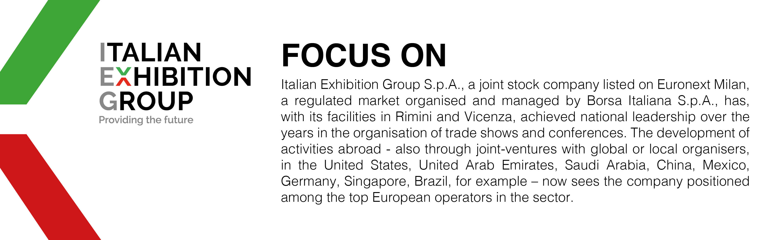

This press release contains forecast elements and estimates that reflect the management’s current opinions (“forward-looking statements”), particularly regarding future management performance, realization of investments, cash flow trends and the evolution of the financial structure. For their very nature, forward-looking statements have a component of risk and uncertainty, as they depend on the occurrence of future events. The effective results may differ (even significantly) from those announced, due to numerous factors, including, only by way of example: food service market and tourist flow trends in Italy, gold and jewellery market trends, green economy market trends; the evolution of raw material prices; general macroeconomic conditions; geopolitical factors and evolutions in the legislative framework. Moreover, the information contained in this release does not claim to be complete, and has not been verified by independent third parties. Forecasts, estimates and objectives contained herein are based on the information available to the Company as at the date of this release.

(Export Report 2023 – Sace)

